# The Messenger

## of Trinity Baptist Church

## june-July, 2020

Join us and invite your family and friends to Vacation Bible School,

July 6th-10th, 9 am – Noon.

We will enjoy a week of fun, fellowship, and learning about Jesus and His love for us.

[](https://www.google.com/url?sa=i&url=http://gatorchurch.com/event/vbs-2020/&psig=AOvVaw1GLjwcjhqa1tdp0HQ7HHjp&ust=1591809254068000&source=images&cd=vfe&ved=0CAIQjRxqFwoTCKjQ-7ae9ekCFQAAAAAdAAAAABAD)

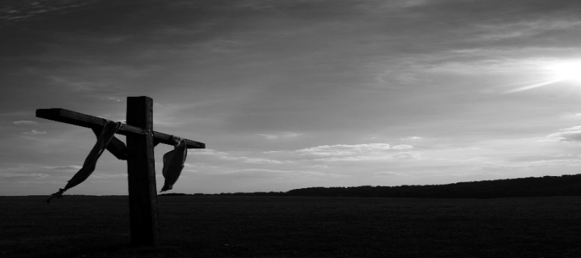

Family Fun Nights

Join us on sunday evenings for a time of fellowship and fun.

we will have a different family activity planned for each week throughout the summer. check out the church website or facebook page for details of the coming week.

this is a great opportunity to gather together as a church family and reconnect.

**we have missed you !!!!**

Below is a tentative schedule of activites. These are subject to change.

June 28th, 5:30 pm: guernsey trail. you can choose to walk or ride a bike.

July 5th, 5:30 pm: family scavenger hunt, ice cream sundae bar. (please bring your favorite ice cream topping).

july 12th, 5:30 pm: salt fork beach/kayaking.

July 19th, 5:30 pm: cookout at the 209 property.

july 26th, 5:30 pm: cornhole competition. get your team together now.

august 2nd, 5:30 pm: putt putt/bowling, zanesville.

august 9th, 5:30 pm: end of summer bash.

Build Team Update



Exciting news:

We will soon be breaking ground!!!!

Our Contractor has contacted us and they have opening to begin site work on the building. This will include bringing the utilities over and capping them and preparing the property for whenever we are ready to begin building.



Youth Summer Camp 2020 will be held at the Rt. 209 property on July 23rd, 24th, & 25th. Join us for 3 days of Chapel, games, fellowship, and fun. Cost is $25.00 which needs to be paid by Sunday, July 19th. See Pastor Brian for more details.

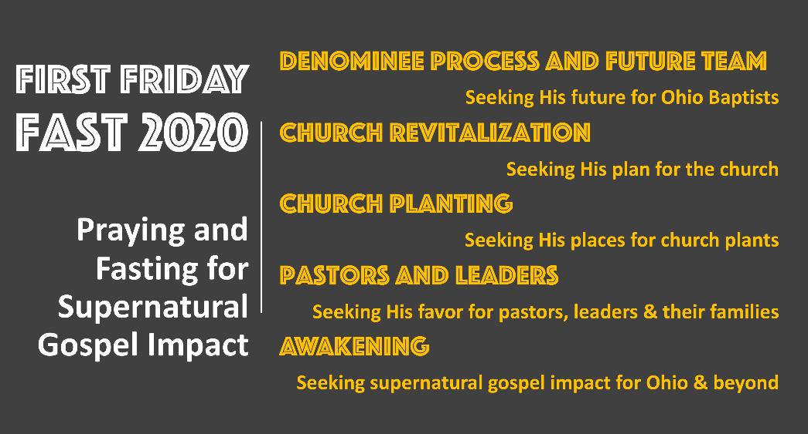

Coming events

Don’t forget to let them know you are thinking of them.

*Praying and Fasting for Supernatural Gospel Impact in Ohio and beyond!*

*We should never discount the power of prayer. As much as we strategize and prepare our work for God’s mission, we cannot forget that apart from Christ, we can do nothing (John 15:5). If we want to bear much fruit throughout Ohio, we must commit to praying. Think about all of the efforts right now in our state: the Denominee process starting in January to bring clarity to our convention’s ministry, increased church planting and revitalization efforts, and the every-day work of our church’s carrying out the Great Commission. We must pray!*

*As I think about our work in 2020, I want to challenge our churches to a prayer effort that will be low burden and high impact. So, let me introduce you to the* ***First Friday Fast*** *effort, where I trust our churches will commit to fasting (if physically able) and praying on the first Friday of every month in 2020. We are providing five prayer points to consider as you pray and fast. Imagine what the Lord might do as we seek and depend on Him as we carry out His mission!*

***Will you join us in the First Friday Fast challenge in 2020?***

Ryan Strother

*Pastor Central Baptist, Marion, SCBO President*

June 28th: CREW Intern will be speaking on her opportunity and need for sponsorship.

July 3rd: First Friday Fast.

July 6th-10th: VBS, 9:00 am-Noon.

July 8th: Business Meeting, 7:00 pm.

July 11th: Cleaning Team Work Day.

July 23rd-25th: Youth Summer Camp at the new property.

Please continue to pray for our Pastors and Church family as we navigate this pandemic. There are no precedents to follow, and information changes daily. We are so thankful for all of you and your support.